1. Frontend, Backend, and Full-Stack Development
- Frontend: The client-side (browser) code; focuses on the user interface (UI) and user experience (UX). Technologies: HTML, CSS, JavaScript. Example: The layout and buttons on a website.
- Backend: The server-side code; focuses on business logic, data processing, and security. Technologies: Python, Node.js, databases. Example: Processing a payment or retrieving a user profile.
- Full-Stack: A developer who works proficiently across both the frontend and the backend.
2. Simple Diagram of the Client-Server Model
The Client (e.g., your browser) sends a Request over the Internet to the Server, and the Server executes the logic and sends back a Response (e.g., the web page content).
3. Browser Request and Display Process
- DNS Lookup: Browser finds the server's IP address.
- HTTP Request: Browser sends a request to the server.
- Server Processing: Server generates the required content.
- HTTP Response: Server sends back HTML, CSS, and JS files.
- Rendering: Browser interprets the files to draw the final web page on the screen.
4. Web Development Environment Tools
Tool | Purpose
Code Editor (VS Code) | Writing, editing, and managing source code (HTML, CSS, JS).
Web Browser (Chrome DevTools) | Viewing, testing, and debugging the front-end code.
Git | Tracking changes, collaborating, and managing code history (Version Control).
npm/Yarn | Installing and managing code libraries and dependencies (Package Manager).

5. Web Server Definition and Examples
A Web Server is software that stores web content and delivers it to clients (browsers) in response to HTTP requests. Its core function is to serve files.
- Examples: Apache HTTP Server, Nginx, Microsoft IIS.
6. Roles in a Project
- Frontend Developer: Implements the user-facing visual and interactive components.
- Backend Developer: Writes the application logic, manages server resources, and handles data security.
- Database Administrator (DBA): Designs, maintains, and ensures the security and performance of the database system.

7. VS Code Installation and Configuration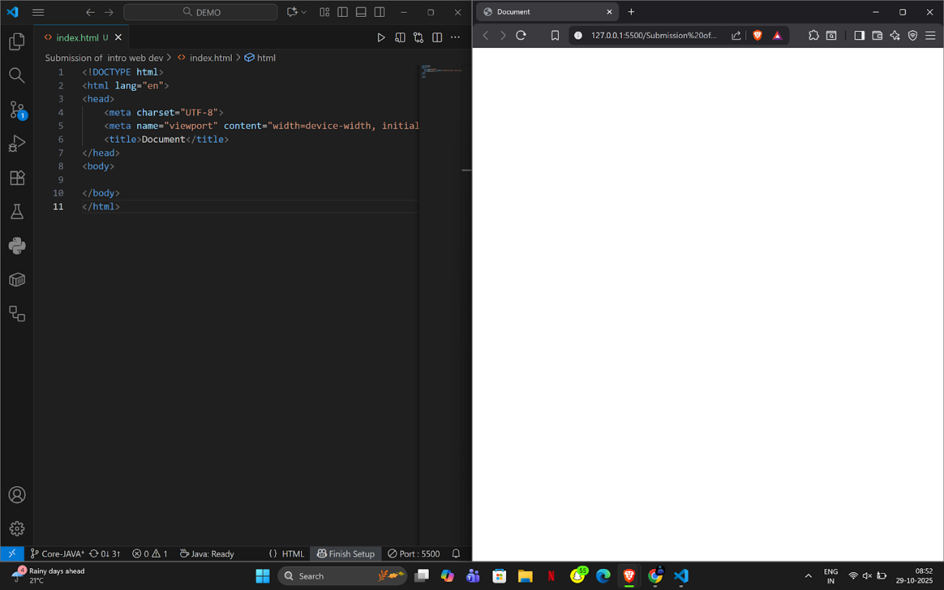

8. Static vs. Dynamic Websites
Feature | Static Website | Dynamic Website
Content | Fixed; pre-built HTML files. | Changes based on user/data; generated on request.
Data Source | Files on the server. | Database access required for generation.
Example | Simple company brochure or portfolio. | E-commerce store or social media platform.

9. Five Web Browsers and Rendering Engines
Browser | Rendering Engine | Key Difference
Chrome | Blink | Fast, Google-developed, based on WebKit.
Firefox | Gecko | Independent, Mozilla-developed, emphasizes privacy.
Safari | WebKit | Apple-developed, optimized for Apple hardware.
Edge | Blink | Uses the same core engine as Chrome for compatibility.
Opera | Blink | Shares the core engine with Chrome.
Rendering Engines are the core that interprets HTML/CSS/JS and draws the page. They differ based on their underlying codebases, optimization goals, and interpretation of web standards.

10. Basic Web Architecture Flow Diagram
The data and process flow through the main components is:
Client → Server (Application Logic) → Database (Fetch/Store Data) / APIs (External Services) → Server (Final Assembly) → Client (Display)

